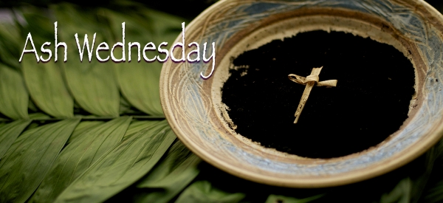
Beginning the Season of Lent, we worship for the annual Ash Wednesday observance at 7:30 pm on February 14th in the Sanctuary of the Presbyterian Church at Shrewsbury. We will be participating in Communion through Intinction and will have the opportunity to receive Ashes on forehead or palm, if desired, the ashes being made from the Palm Fronds of last year’s Palm Sunday. All are welcome as we begin this season of reflection and reconnection with God in the Journey to Jerusalem.

